We thank thee, O God, for a prophet

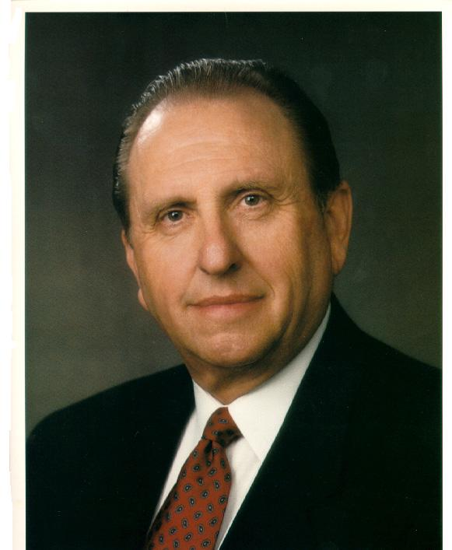

To guide us in these latter-days.
We thank thee for sending the gospel
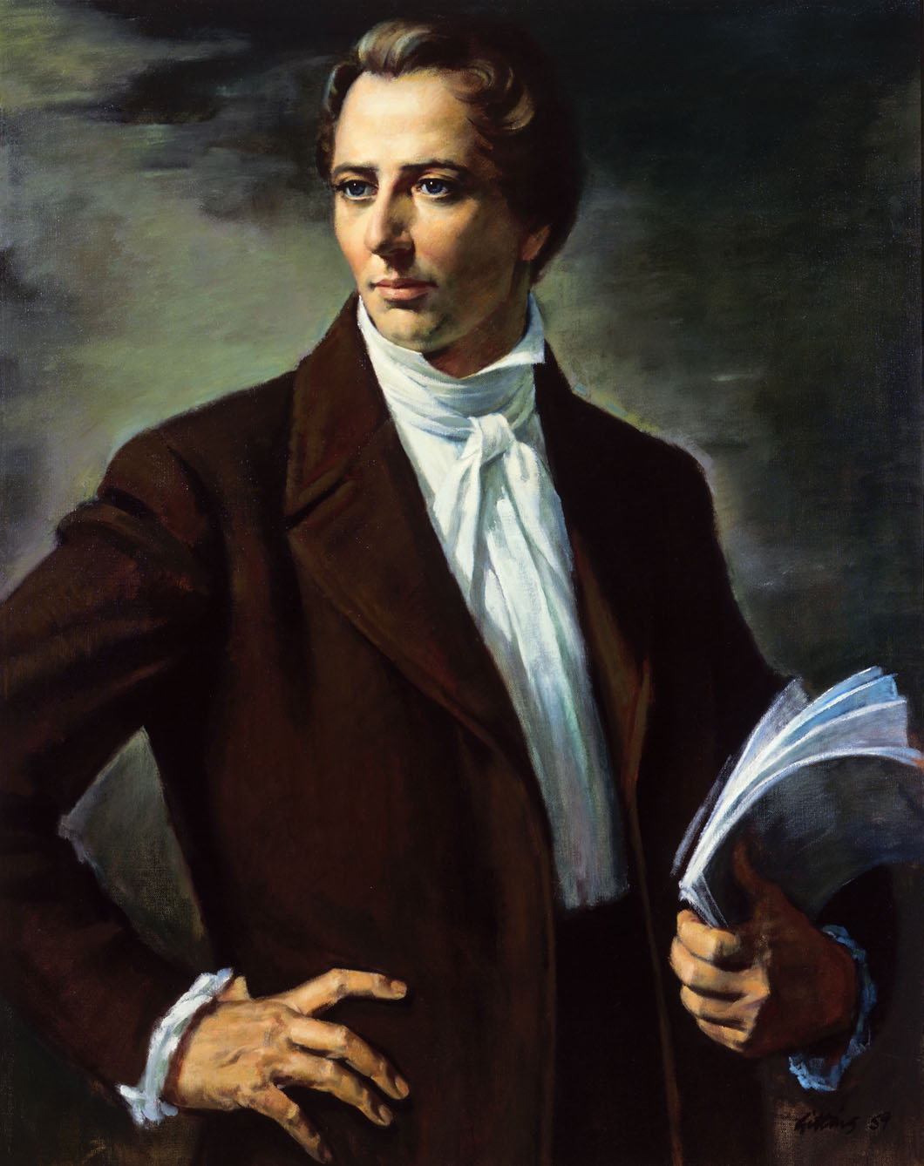

To lighten our minds with its rays.

We thank thee for every blessing
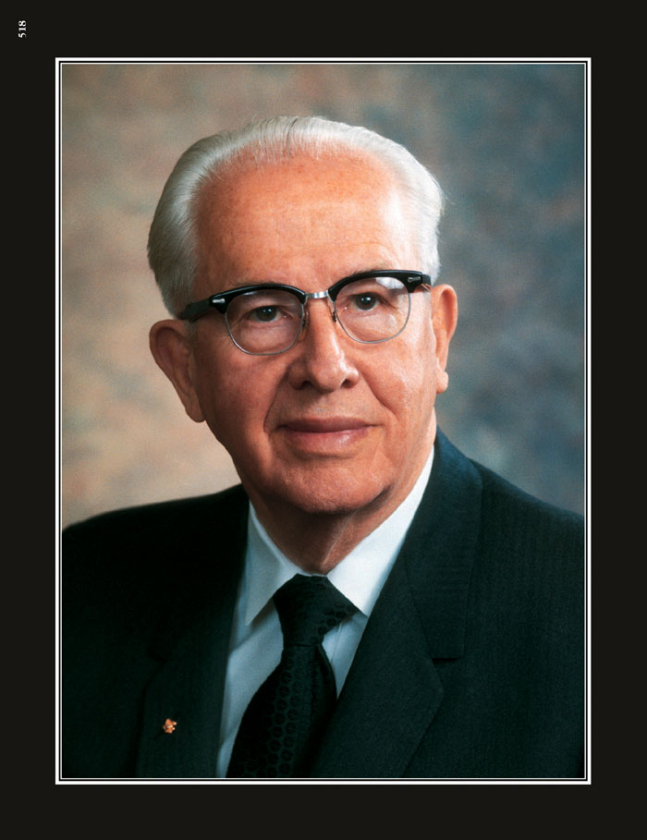
Bestowed by thy bounteous hand.
We feel it a pleasure

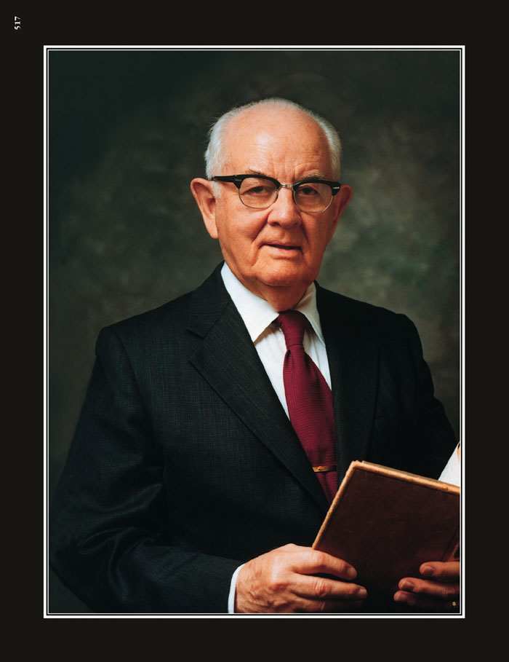

to serve thee

and love to obey

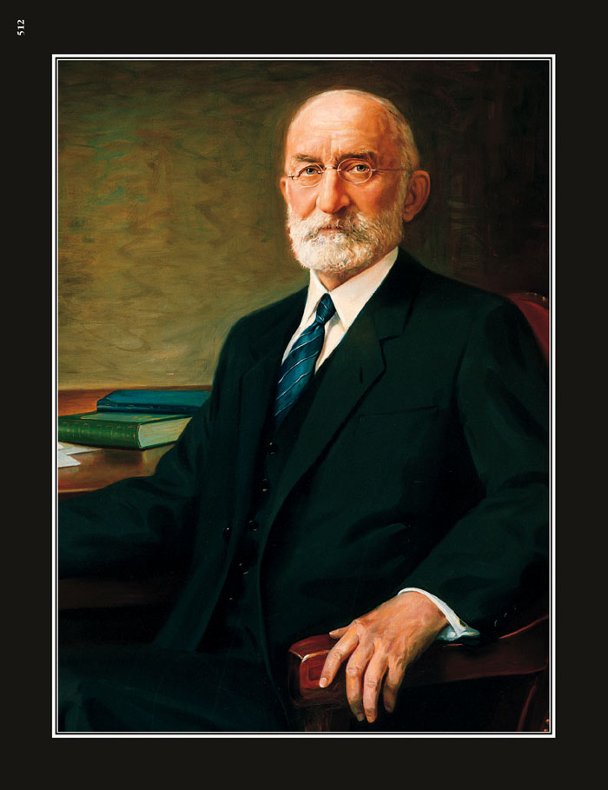

thy command.
When dark clouds of trouble hang o’er us
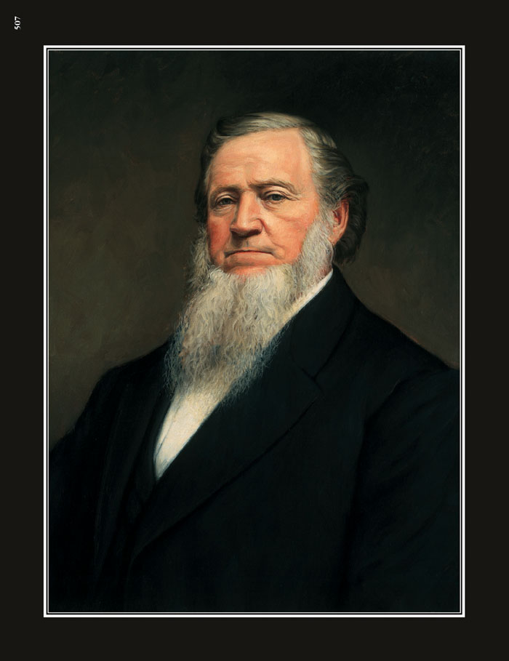

And threaten our peace to destroy,
There is hope smiling brightly before us,
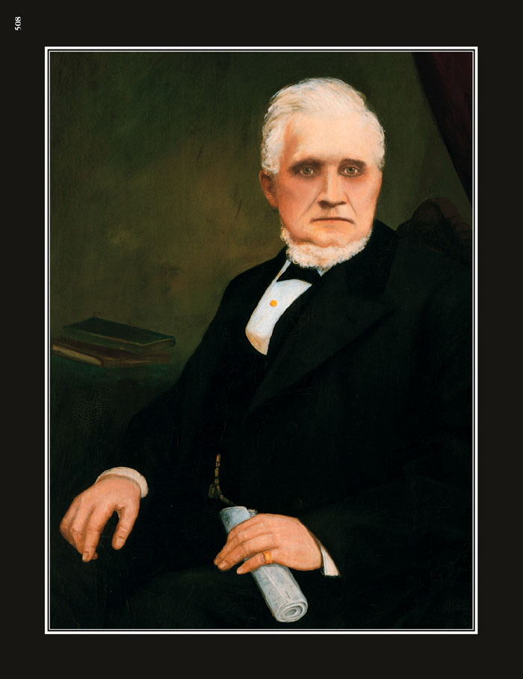

And we know that deliv’rance is nigh.
We doubt not the Lord

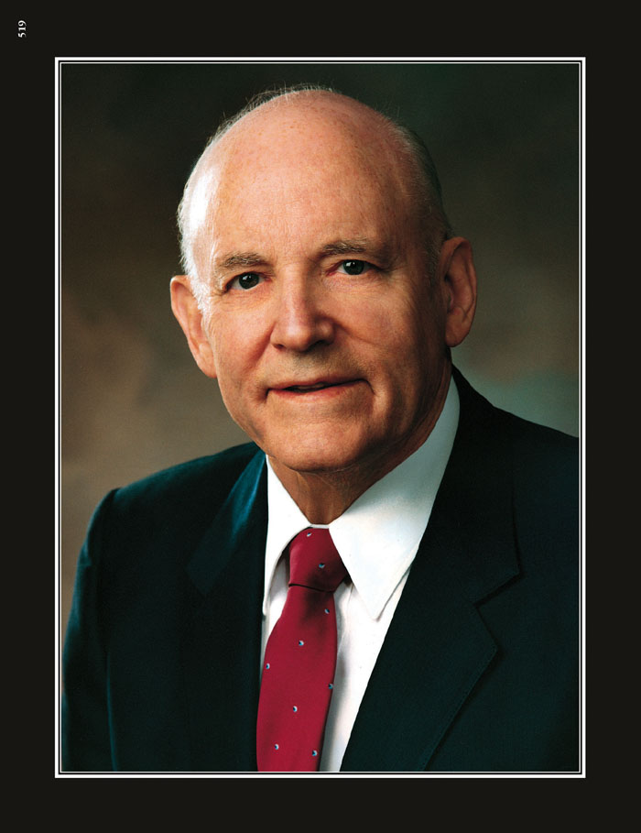

nor his goodness.
We’ve proved him in

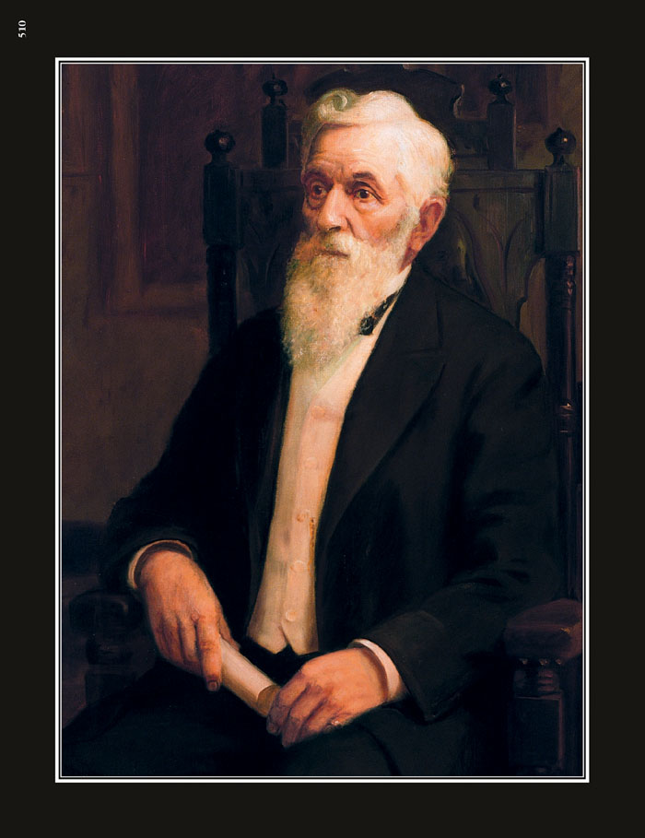

days that are past.
The wicked who fight against Zion
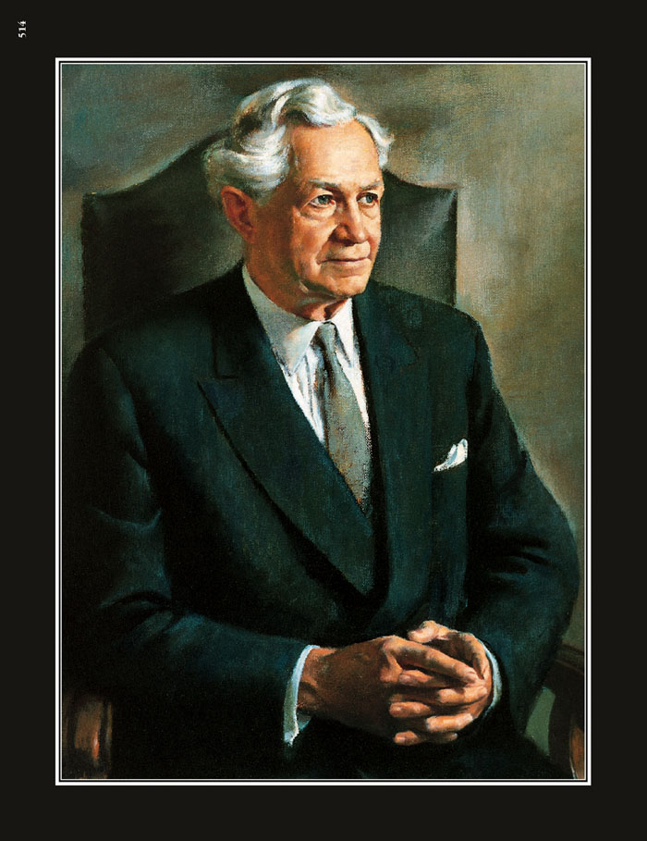

Will surely be smitten at last.
We’ll sing of his
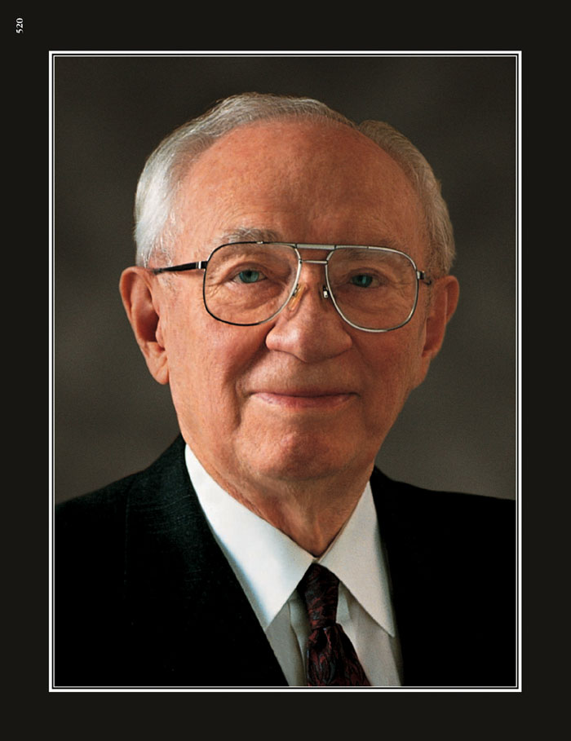

goodness and mercy.

We’ll praise him by

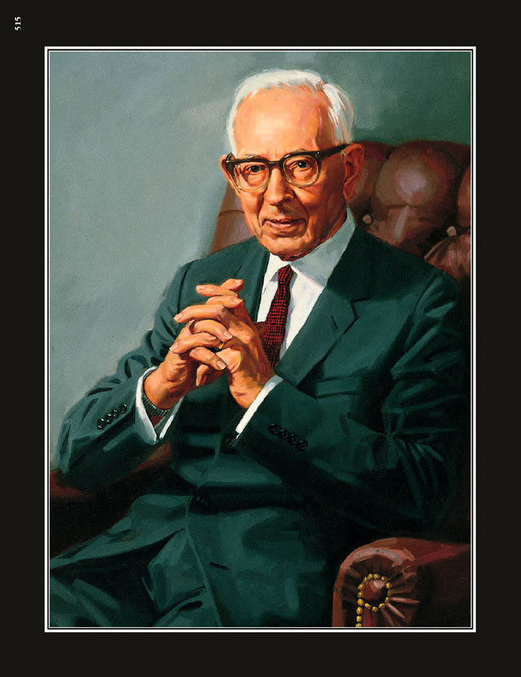

day and by night,
Rejoice in his glorious gospel,
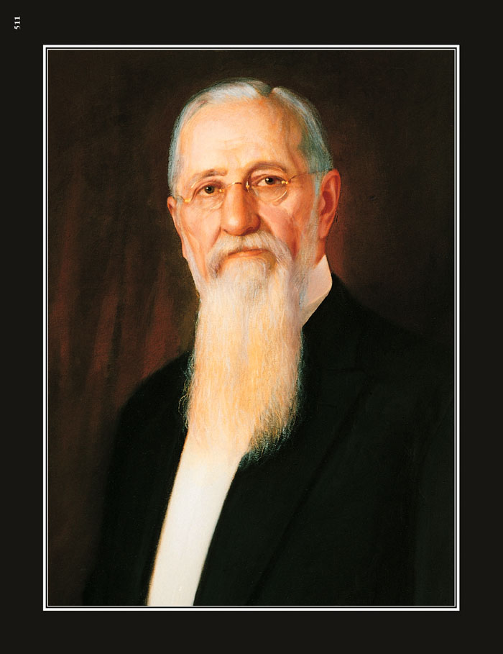

And bask in its life-giving light.
Thus on to

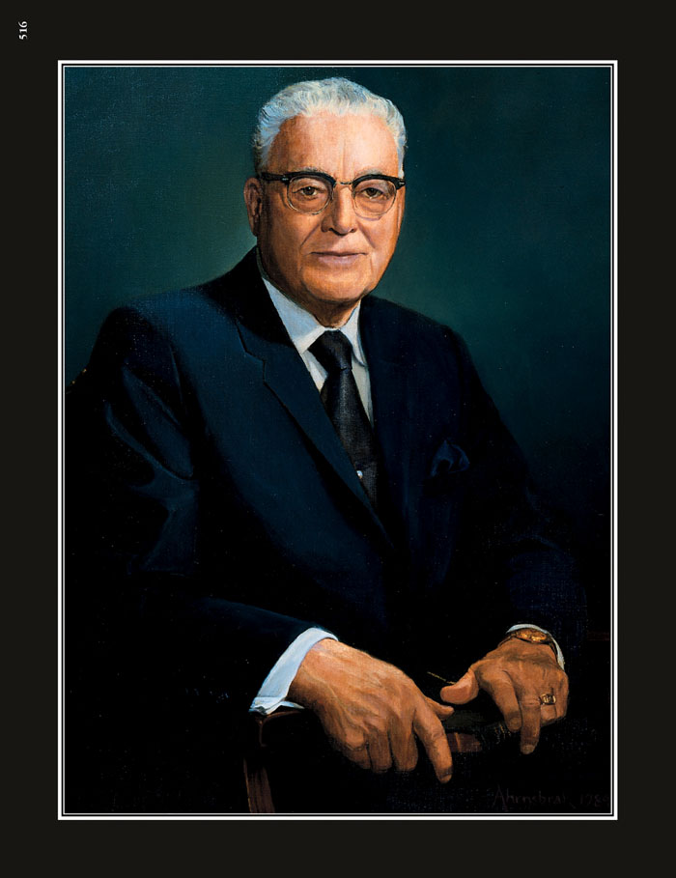

Eternal perfection

The honest

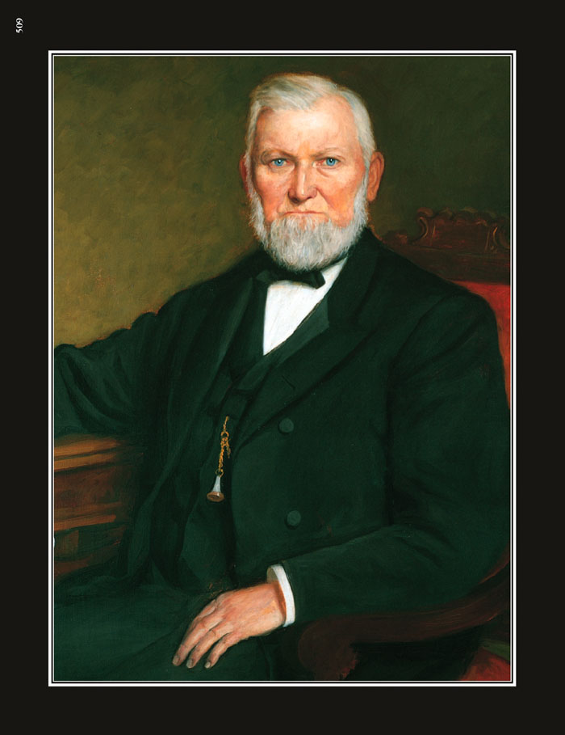

and Faithful will go,

While they who reject this glad message
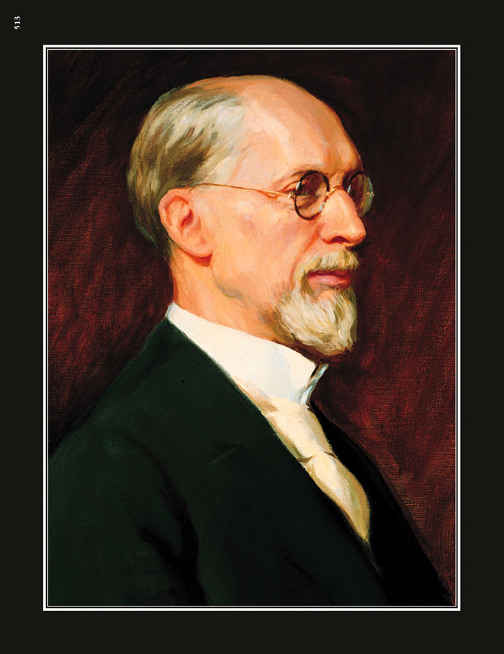
Shall never such happiness know.

President Monson: We thank thee O God, for a prophet, to guide us in these latter-days.
We have a new prophet. Some neat things about President Monson that you might not know is that he has an excellent memory and can quote scriptures without help from memory. My favorite President Monson quote is "Work will win when wishy washy wishing won t." That means that sitting around and doing nothing isn’t going to do any good!

Joseph Smith: We thank for sending the gospel to lighten our mind with it’s rays
Joseph Smith was our first prophet. He was the one that Heavenly Father chose to send the gospel to first - for all of us. He made it possible to us to have the Book of Mormon - to “lighten” our minds (to teach us).

Ezra Taft Benson: We thank thee for every blessing Bestowed by thy bounteous hand
President Benson was 13th president of the church. He wanted everyone to understand how important the Book of Mormon was. He said: ”The Book of Mormon will sweep the earth like a flood. Indeed I have a vision of flooding the earth with the Book of Mormon.” The Book of Mormon is a blessing to us and to the world.

Spencer W. Kimball: We feel it a pleasure to serve thee
Was the 12th president of the church. He taught members to serve. He had a plaque on his desk which read “DO IT” He wanted us to get out and DO service.
Heber J. Grant: and love to obey thy command
President Grant was baptized in a Wagon box set rigged up as an outdoor font behind Brigham Young’s school in Salt Lake City. He was baptized in 1864. When President Grant gave his first conference talk he said: Keep the commandments of God. That is my speech, just those few words.”

Brigham Young: When dark clouds of trouble hang o’er us And threaten our peace to destroy.
Brigham Young, second President of the Church, was the pioneer leader who guided the Saints west to the Salt Lake Valley. That was a very dark and scary time for the Saints. He sent families to establish towns and colonies throughout the West. He taught the people to stand for truth and righteousness, to work hard, and to be educated.

John Taylor: There is hope smiling brightly before us and we know that deliverance is nigh.
3rd President. John Taylor was in Carthage jail with Joseph Smith. He was shot several times.. After a bullet struck him, he started falling out the window of his jail cell. Another bullet struck his watch and the blow forced him back in the room. He said: “I felt that the Lord had preserved me by a special act of mercy, that my time had not yet come and that I had still a work to perform upon the earth” It was a hard time for John Taylor, he had lost his best friend, Joseph Smith. But he had hope-and he knew Heavenly Father had delivered him or a great work. No matter what our troubles are there is always hope and we can count on Heavenly Father to deliver us if we ask.

Howard W Hunter: We doubt not the Lord nor his goodness,
14th President He grew up in Boise, Idaho. His mother was a member of the church, but his father was not a member. When Howard turned eight-years-old, he wanted to be baptized, but his father explained that he wanted him to wait until he grew up so he could decide for himself which church to join. He never doubted that the Lord would soften his dad’s heart so he could get baptized. When Howard turned twelve, he begged his father to let him be baptized so he could become a deacon. Finally, a few months after Howard’s twelfth birthday, his father agreed to let him be baptized. He was baptized on April 4, 1920 in a big public swimming pool.

Lorenzo Snow: We proved him in days that are past.
5th President. When he was prophet he proved to the Saints living in St. George, Utah that the Lord would bless them if they follow his counsel. They really needed some rain so their crops would grow or they might starve. He told them that the Lord instructed him to tell the Saints to pay a full tithing and they would be blessed. After waiting for two long months, the Saints never lost faith and not only were they paying their tithing—they were giving even MORE than a 10th. They finally did get rain and were able to harvet all their crops in the fall!

David O. McKay: The wicked who fight against Zion Will surely be smitten at last.
Was our 9th prophet. He taught us the best way to fight wickedness is to have a righteous home. Even though there are wicked things that happen in our world Heavenly Father will always protect us.
He always reminded saints that "no other success can compensate for failure in the home"
“Every member a missionary,"
Gordon B. Hinckley: We will sing of his goodness and Mercy
15th President
President Hinckley was a good man. He was a happy, optimistic person who believed there was a spark of divinity within all of us. He called on us to be grateful, smart, clean, true, humble, and prayerful. He counseled us to stand a little taller, to be strong, decent, courteous, and above all, more Christlike.

Joseph Fielding Smith: We’ll praise him by day and by night.
Joseph Fielding Smith was out 10th President. His parents told him pioneer stories and taught him to pray day and night.
He said, “ ‘I learned at a very early day that God lives. He gave me a testimony when I was a child and I have tried to be obedient.
He left this blessing on the youth of the Church: "The Lord bless you and keep you…. Be true to every trust. Honor thy father and thy mother. Dwell together in love…. Be modest in your dress. Overcome the world, and do not be led astray by the fashions and practices of those whose interests are centered upon the things of this world"

Joseph F. Smith: Rejoice in his glorious gospel and bask in his life giving light.
He was our 6th president in 1901. That was more than 100 years ago. We rejoice in a new gospel principle that President Smith taught us. He had a very important vision just 6 weeks before he died. The vision showed Christ visiting the spirits of the righteous spirits of people who had died. The spirits who had died where teaching the people who hadn’t heard about the gospel while on the earth. Among the people he saw that were teaching his own father Hyrum Smith and the Prophet Joseph Smith. This vision is now scripture in DC 138.

Harold B. Lee: Thus on to Eternal Perfection
“I remember a little boyhood experience. We had pigs that were tearing up the garden, causing great mischief on the farm. Father sent me two miles to the store to get an instrument so we could ring the noses of the pigs. Then they couldn’t cause so much trouble.
We had great difficulty rounding them up and getting them in the pen, and as I was fooling around with this instrument that I had been sent to purchase, I pressed down too hard and it broke.
Father would have been justified in giving me a scolding right there, after all the effort and money wasted, but he just looked at me, smiled, and said, “Well, son, I guess we won’t ring the pigs today. Turn them out and we’ll go back tomorrow and try it over again.”
How I loved that father, that he didn’t scold me for an innocent little mistake that could have made a breach between us. We can become perfect like Heavenly Father. But we just try every day a little bit.. We can be patient just like President Lee’s father and make our home a happy place.
Wilford Woodruff: Be honest and Faithful will go
Because of his faithfulness, humility, and willingness to serve always, he was called Wilford the faithful. He was baptized just 2 days after the missionaries taught him about the church. We can be faithful and honest in all we do and follow his great example.
While driving two horses pulling a sled to the baptism, several loose boards on the floor of the sled gave way, and Wilford suddenly fell to the ground. With Wilford holding onto the harness with all his might, the two frightened horses raced down a hill, dragging him along. Luckily, the ground was slick with snow, and he stopped the horses without serious injury. When Wilford finally got to the lake, the ground was covered with three feet of snow. Chunks of ice were floating in the water. Nevertheless, Wilford eagerly stepped into the water, was baptized by immersion, and came up filled with joy and excitement. He made a promise to the Lord that day to do anything, go anywhere, and sacrifice everything, if need be, for his Heavenly Father.
George Albert Smith: While they who reject his glad message shall never such happiness know.
President Smith decided he wanted to be a friend to all. He recognized that not everyone would accept the gospel, but he made a commitment to kind to everyone even if they were not nice to him. He said “ I would not be an enemy to any living soul. I would seek to do him good and make him my friend.”

