draw a pioneer wagon like the one shown using the grids as a guide.
Draw a pioneer wagon like the one shown using the grids as a guide.

Draw a pioneer wagon like the one shown using the grids as a guide.
Draw a pioneer wagon like the one shown using the grids as a guide.
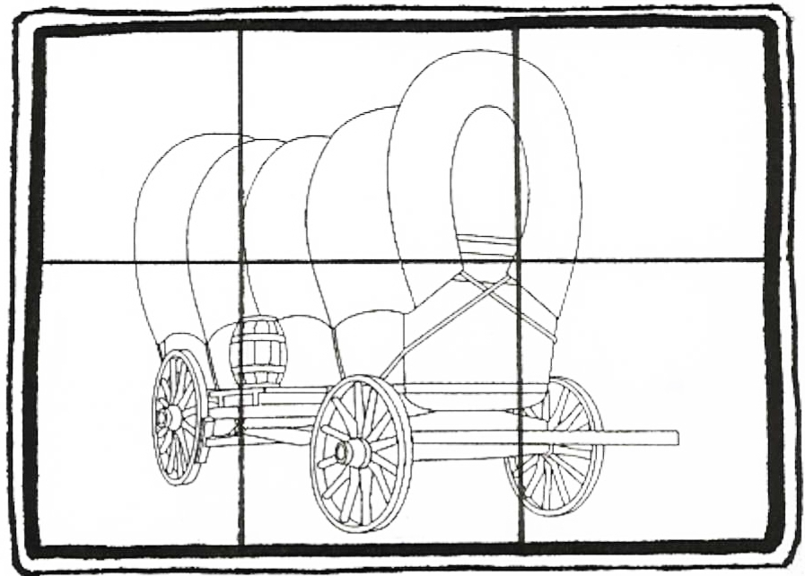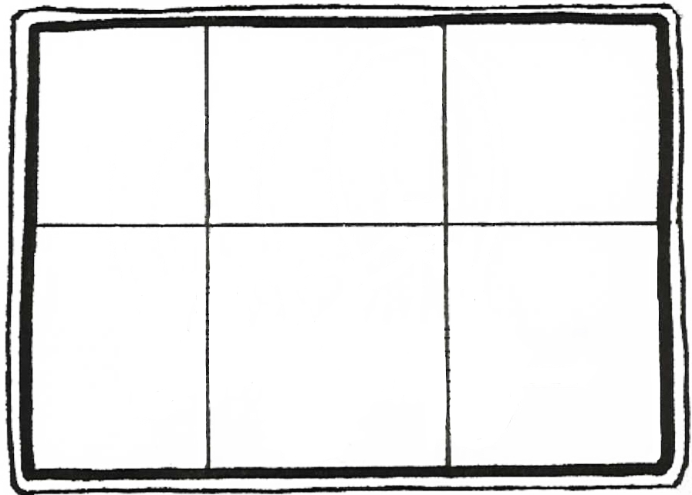

Lesson
40
Lesson
40
Lesson
40

Lesson
40

Draw a pioneer wagon like the one shown using the grids as a guide.

