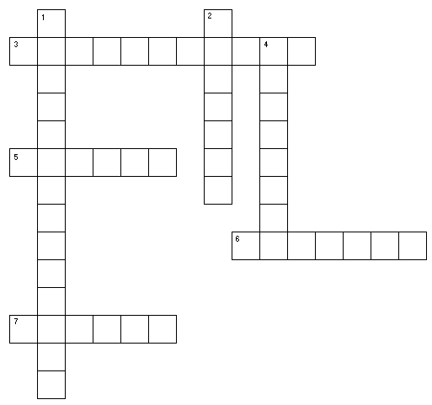

What We Learn from the First Vision
1. We are made in the image of ________ and Jesus Christ.
2. Heavenly Father’s power is ________ than Satan’s power.
3. ________ is Heavenly Father’s Son.
4. Heavenly Father and Jesus are two ________ personages.
5. Heavenly Father will ________ our sincere prayers.
6. Satan is real and wants to ________ the work of Heavenly Father and Jesus.
7. Jesus told Joseph that no ________ then on the earth was true.

