“So You Think You
Know the Scriptures”
Quiz Game
Questions:

Where in the World Is _________?

- Where in the world is the place where the Gold Plates were buried until Moroni instructed Joseph Smith, Jr. to dig them up? Name it and find it on the map.
(Joseph Smith History 1:51-52, Pearl of Great Price page 54, Map 2)

- Where in the world is the place where Jesus walked on the water? Name it and find it on the map.
(John 6:17-20, New Testament page 1335, Map 11)

- Where in the world is the body of water that John the Baptist baptized Jesus in? Name it and find it on the map. (Mark 1:9-11, New Testament page 1242, Map 11)

- Where in the world is the place where the Latter-day saints built the first temple? Name it and find it on the map. (D&C Section 95, pages 185-186, Map 4)

Scripture Heroes

- Which prophet was a hero of the Israelites when he saved them from slavery in Egypt and parted the Red Sea? (Exodus chapter 14, Old Testament pages 99-101)

- Which war hero led the 2,000 stripling warriors of the Ammonite people in battle? (Alma 53:16-22, Book of Mormon page 343-344)

- Which Book of Mormon hero was made chief captain of all the Nephite armies when he was only 25-years-old and spent the remainder of his life uniting and protecting his people under the Title of Liberty?
(Alma46:11-13, Book of Mormon page 323)
- Which Old Testament hero saved the Jewish people by fasting and prayer and by illegally going in to the king to uncover a wicked plot to kill all the Jews in the land? (Hint: she’s a she-hero.)(Esther 4:15-16, Old Testament page 673)

Primary Scriptures

- What does the Primary scripture from January tell us about ourselves? (For JUNIOR: In whose image were we created?) (Proclamation paragraph 2)

- What does the Primary scripture from May tell us is central to the creator’s plan for the eternal destiny of his children? (Proclamation paragraph 1)

- The Primary scripture from June talks about building a house in the Lord’s name that is used for revealing ordinances. What kind of house does it mean?
(D&C 124:40, page 249)

- The Primary scripture for this month (October) tells us that we should serve the Lord with four things. What are they? (D&C 4:2, page 7)

Commandments and Other Words of Wisdom

- Which is the first and greatest commandment?
(Matthew 22:37-38, New Testament page 1227)

- If we honor our fathers and mothers what will be our reward? (Exodus 20:12, old Testament page 110)

- Name 3 commandments that God gave to Moses on Mt. Sinai? (Exodus 20:3-17, Old Testament pages 109-110)

- What blessings are we promised if we follow the Word of Wisdom? (D&C 89:18-21, page 176)
“So You Think You Know the Scriptures”
Quiz Game
Answers:

Where in the World Is _________?
- Hill Cumorah, C-4 #5
- Sea of Galilee, C-3 #5
- River Jordan, C-5 #12
- Kirtland, B-4 #7

Scripture Heroes
- Moses
- Helaman
- Moroni
- Esther

Primary Scriptures
- created in the image of God, beloved sons and daughters of heavenly parents, have a divine nature and destiny
- the family
- a temple
- heart, might, mind, and strength

Commandments and Other Words of Wisdom
- Thou shalt love the Lord thy God with all thy heart, and with all they soul, and with all they mind.
- Our days may be long upon the land
- Thou shalt have no other gods before me, thou shalt not make unto thee any graven image, thou shalt not take the name of the Lord thy God in vain, remember the Sabbath day to keep it holy, honour thy father and thy mother, thou shalt not kill, thou shalt not commit adultery, thou shalt not steal, thou shalt not bear false witness, thou shalt not covet
- Receive health in the navel and marrow to the bones, find wisdom and great treasures of knowledge, run and not be weary, walk and not faint, the destroying angel shall pass by
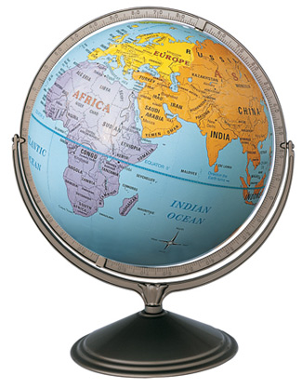

Where in the World
is…?

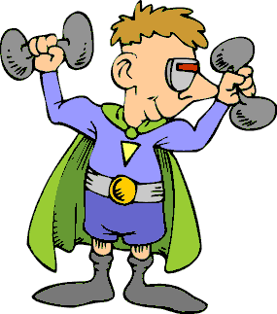

Scripture Heroes

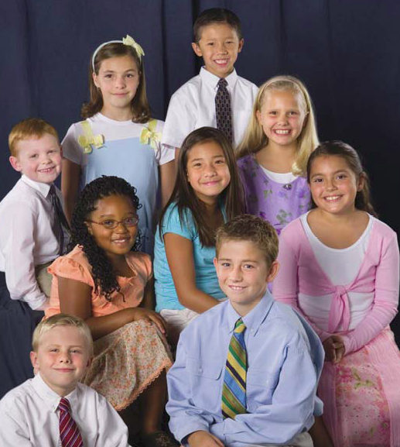

Primary Scriptures
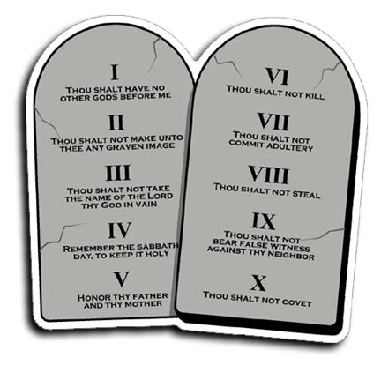

Commandments
and Other
Words of Wisdom
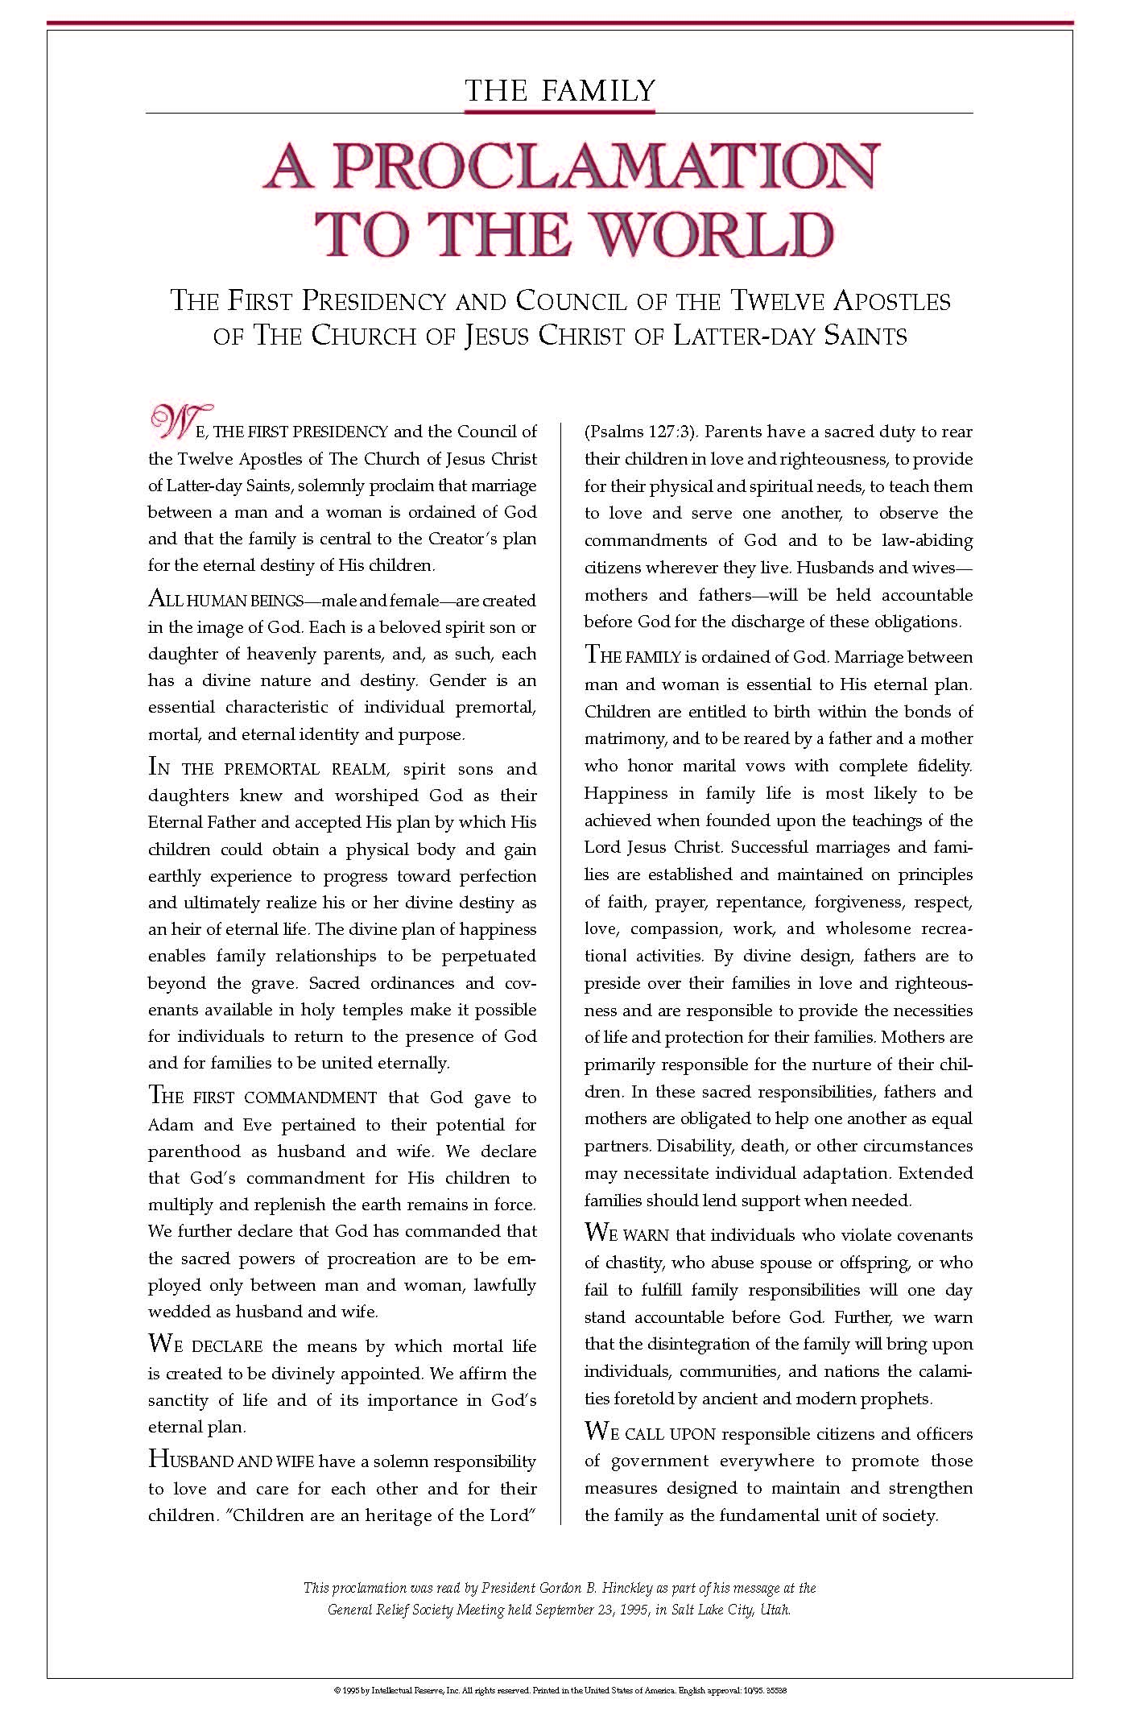
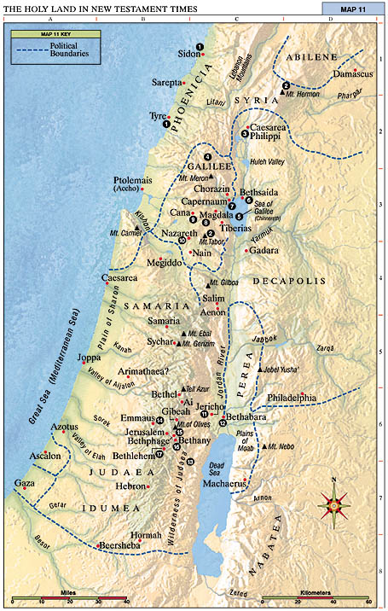
1. Tyre and Sidon Jesus compared Chorazin and Bethsaida to Tyre and Sidon (Matt. 11:20-22). He healed the daughter of a Gentile woman (Matt. 15:21-28).
2. Mount of Transfiguration Jesus was transfigured before Peter, James, and John, and they received the keys of the kingdom (Matt. 17:1-13). (Some believe the Mount of Transfiguration to be Mount Hermon; others believe it to be Mount Tabor.)
3. Caesarea Philippi Peter testified that Jesus is the Christ and was promised the keys of the kingdom (Matt. 16:13-20). Jesus foretold his own death and Resurrection (Matt. 16:21-28).
4. Region of Galilee Jesus spent most of his life and ministry in Galilee (Matt. 4:23-25). Here he gave the Sermon on the Mount (Matt. 5-7); healed a leper (Matt. 8:1-4); and chose, ordained, and sent forth the Twelve Apostles, of whom only Judas Iscariot was apparently not Galilean (Mark 3:13-19). In Galilee the risen Christ appeared to the Apostles (Matt. 28:16-20).
5. Sea of Galilee, later called Sea of Tiberias Jesus taught from Peter’s boat (Luke 5:1-3) and called Peter, Andrew, James, and John to be fishers of men (Matt. 4:18-22; Luke 5:1-11). He also stilled the tempest (Luke 8:22-25), taught parables from a boat (Matt. 13), walked on the sea (Matt. 14:22-32), and appeared to his disciples after his Resurrection (John 21).
6. Bethsaida Peter, Andrew, and Philip were born in Bethsaida (John 1:44). Jesus went away privately with the Apostles near Bethsaida. The multitudes followed him, and he fed the 5,000 (Luke 9:10-17; John 6:1-14). Here Jesus healed a blind man (Mark 8:22-26).
7. Capernaum This was Peter’s home (Matt. 8:5, 14). In Capernaum, which Matthew called Jesus’ “own city,” Jesus healed a paralytic (Matt. 9:1-7; Mark 2:1-12), cured a centurion’s servant, healed the mother of Peter’s wife (Matt. 8:5-15), called Matthew to be one of his Apostles (Matt. 9:9), opened blind eyes, cast out a devil (Matt. 9:18-33), healed a man’s withered hand on the Sabbath (Matt. 12:9-13), gave the bread-of-life discourse (John 6:22-65), and agreed to pay taxes, telling Peter to get the money from a fish’s mouth (Matt. 17:24-27).
8. Magdala, Magadan This was the home of Mary Magdalene (Mark 16:9). Soon after Jesus came here after feeding the 4,000 (Matt. 15:38-39), the Pharisees and Sadducees requested that he show them a sign from heaven (Matt. 16:1-4).
9. Cana Jesus turned water into wine (John 2:1-11) and healed a nobleman’s son who was at Capernaum (John 4:46-54). Cana was also the home of Nathanael (John 21:2).
10. Nazareth The annunciations to Mary and Joseph took place in Nazareth (Matt. 1:18-25; Luke 1:26-38; 2:4-5). After returning from Egypt, Jesus spent his childhood and youth here (Matt. 2:19-23; Luke 2:51-52), announced his divine Sonship, and was rejected by his own (Luke 4:14-32).
11. Jericho Jesus gave sight to a blind man (Luke 18:35-43). He also dined with Zacchaeus, “chief among the publicans” (Luke 19:1-10).
12. Bethabara John the Baptist testified that he was “the voice of one crying in the wilderness” (John 1:19-28). John baptized Jesus in the Jordan River and testified that Jesus is the Lamb of God (John 1:28-34).
13. Wilderness of Judaea John the Baptist preached in this wilderness (Matt. 3:1-4) where Jesus fasted 40 days and was tempted (Matt. 4:1-11).
14. Emmaus The risen Christ walked on the road to Emmaus with two of his disciples (Luke 24:13-32).
15. Bethphage Two disciples brought Jesus a colt on which he began his triumphal entry into Jerusalem (Matt. 21:1-11).
16. Bethany This was the home of Mary, Martha, and Lazarus (John 11:1). Mary heard Jesus’ words, and Jesus spoke to Martha of choosing the “good part” (Luke 10:38-42); Jesus raised Lazarus from the dead (John 11:1-44); and Mary anointed Jesus’ feet (Matt. 26:6-13; John 12:1-8).
17. Bethlehem Jesus was born and was laid in a manger (Luke 2:1-7); angels heralded to the shepherds the birth of Jesus (Luke 2:8-20); wise men were directed by a star to Jesus (Matt. 2:1- 12); and Herod slew the children (Matt. 2:16-18).
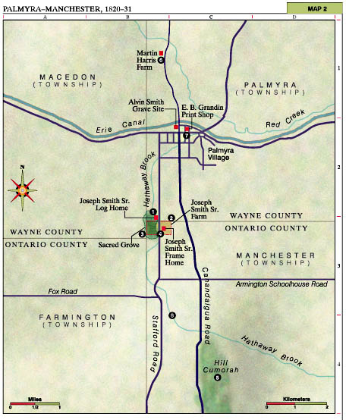

1. Joseph Smith Sr. Log Home The angel Moroni appeared to Joseph Smith in an upper room of this home on 21-22 September 1823 (see JS-H 1:29-47).
2. Joseph Smith Sr. Farm This 100-acre farm was developed by the Smith family from 1820 to 1829.
3. Sacred Grove Joseph Smith Jr.’s First Vision occurred in this woodland in the early spring of 1820 (see JS-H 1:11-20).
4. Joseph Smith Sr. Frame Home This home was begun in 1822 by Alvin Smith and occupied by the Smith family from 1825 to 1829.
5. Hill Cumorah Here the angel Moroni gave the Prophet Joseph Smith the gold plates on 22 September 1827 (see JS-H 1:50-54, 59).
6. Martin Harris Farm This farm was mortgaged and part of its acreage sold to pay for the printing of the Book of Mormon.
7. E. B. Grandin Print Shop 5,000 copies of the Book of Mormon were printed here 1829-30.
8. Hathaway Brook In this brook some early Church baptisms were performed.

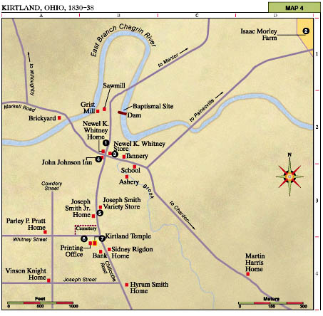
1. Newel K. Whitney Home Joseph and Emma lived here for several weeks after they first moved to Kirtland in 1831.
2. Isaac Morley Farm Joseph and Emma Smith lived here from March until September 1831. The first high priests were ordained here. Joseph worked on the Joseph Smith Translation (JST).
3. Newel K. Whitney Store The First Presidency of the Church was given the keys of the kingdom here. The School of the Prophets first met here. The JST was in the process of completion here in 1833. Joseph and Emma lived here from 1832 to 1833. Joseph received many revelations here.
4. John Johnson Inn Joseph Smith Sr. was called as the first Patriarch to the Church here in 1833. The inn contained the first printing office in Kirtland. The Evening and the Morning Star was printed here following the destruction of the printing press in Jackson County, Missouri. The Twelve Apostles left from here on 4 May 1835 for their first missions.
5. Joseph Smith Jr. Home Joseph and Emma lived here from 1834 to 1837. Translation of the book of Abraham was started.
6. Printing Office The Lectures on Faith were delivered in this building. The Twelve Apostles and the First Quorum of the Seventy were called and ordained here. The Doctrine and Covenants (1st edition), the Book of Mormon (2nd edition), The Evening and the Morning Star, Latter Day Saints’ Messenger and Advocate, and the first issues of Elders’ Journal were printed here.
7. Kirtland Temple This temple was the first in this dispensation. Jesus Christ appeared and accepted the temple. Moses, Elias, and Elijah appeared and restored certain priesthood keys (see D&C 110). The School of the Prophets also met here. Revelations received here: D&C 109, 110, 137.
Kirtland (unspecified locations)
On 17 August 1835 the Doctrine and Covenants was adopted as scripture (see HC 2:243-51). Revelations received in Kirtland include D&C 41-50, 52-56, 63-64, 102-4, 106-10, 134, and 137. Section 104 designates certain properties to be given as stewardships to Church members participating in the united order.

