FOLLOW THE PROPHET
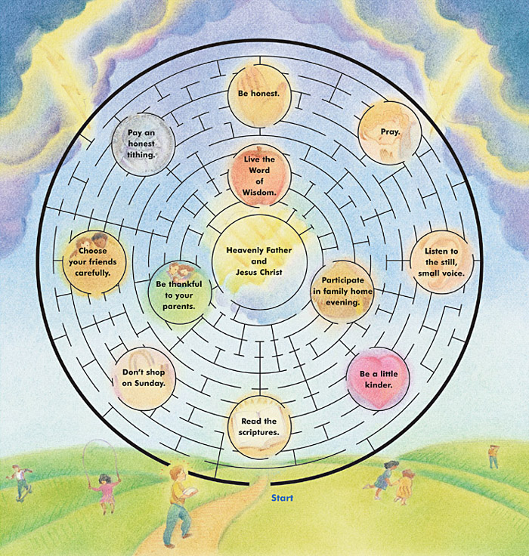
See if you can follow the teachings of President Thomas S. Monson that will lead you through the maze to Heavenly Father and Jesus Christ.

FOLLOW THE PROPHET
See if you can follow the teachings of President Thomas S. Monson that will lead you through the maze to Heavenly Father and Jesus Christ.

FOLLOW THE PROPHET
See if you can follow the teachings of President Thomas S. Monson that will lead you through the maze to Heavenly Father and Jesus Christ.

FOLLOW THE PROPHET
See if you can follow the teachings of President Thomas S. Monson that will lead you through the maze to Heavenly Father and Jesus Christ.

