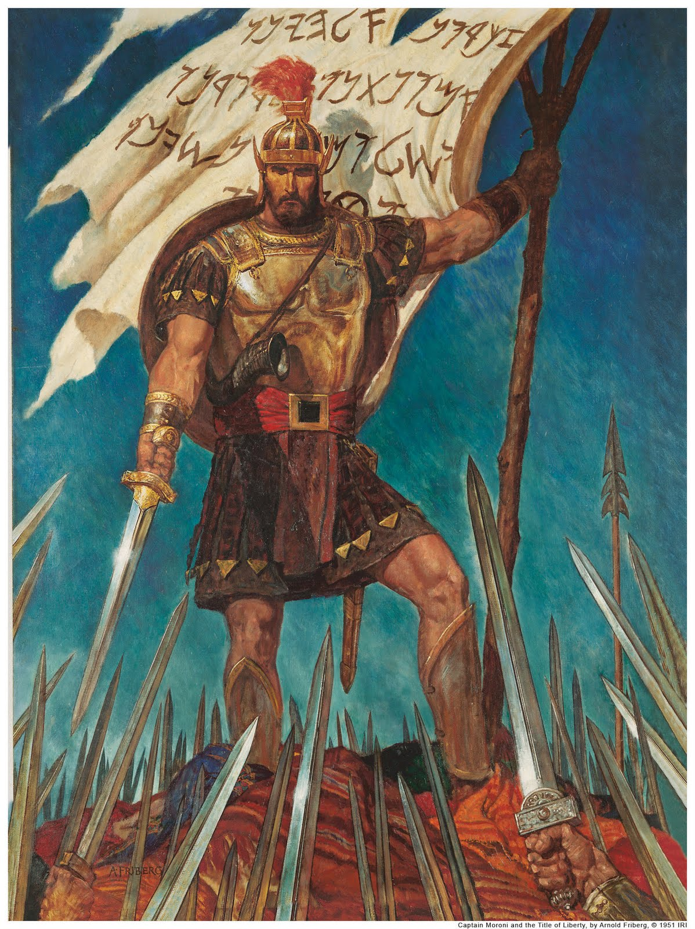


Captain Moroni loved truth, liberty and faith. He devoted his life to helping others preserve their freedom. You can be like Captain Moroni by choosing to stand up for what is right. Look up Alma 48:11-13 and write down some of Moroni’s character traits and write them below:

_______________________________________________________________________________________________________________________________________________________________________________________________________________________________________________________________________________________________________

- Read Alma 46
- Memorize the 12th Article of Faith
Captain Moroni loved truth, liberty and faith. He devoted his life to helping others preserve their freedom. You can be like Captain Moroni by choosing to stand up for what is right. Look up Alma 48:11-13 and write down some of Moroni’s character traits and write them below:

_______________________________________________________________________________________________________________________________________________________________________________________________________________________________________________________________________________________________________
- Read Alma 46
- Memorize the 12th Article of Faith
_______________________________________________________________________________________________________________________________________________________________________________________________________________________________________________________________________________________________________
- Read Alma 46
- Memorize the 12th Article of Faith
_______________________________________________________________________________________________________________________________________________________________________________________________________________________________________________________________________________________________________
- Read Alma 46
- Memorize the 12th Article of Faith
Captain Moroni loved truth, liberty and faith. He devoted his life to helping others preserve their freedom. You can be like Captain Moroni by choosing to stand up for what is right. Look up Alma 48:11-13 and write down some of Moroni’s character traits and write them below:

Captain Moroni loved truth, liberty and faith. He devoted his life to helping others preserve their freedom. You can be like Captain Moroni by choosing to stand up for what is right. Look up Alma 48:11-13 and write down some of Moroni’s character traits and write them below:

