Millions of children around the world belong to The Church of Jesus Christ of Latter-day Saints. They speak different languages, wear different styles of clothes, and live in different kinds of houses. They live on every continent. When we belong to The Church of Jesus Christ of Latter-day Saints, it doesn’t matter where we live, what language we speak, or what kind of building we meet in, because we all believe the same important principles. Put an “x” on the map where you live.
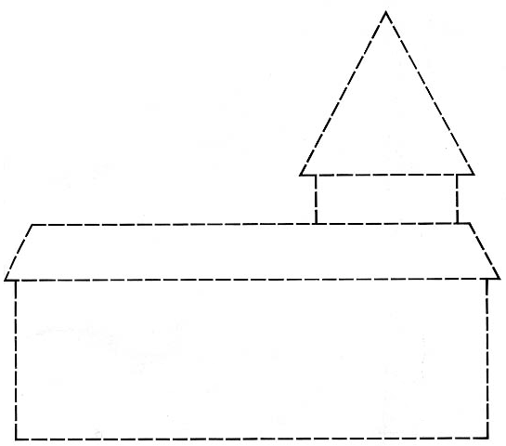
To help you remember the principles on which The Church of Jesus Christ of Latter-day Saints is built, cut out the labeled blocks and glue/tape them where they fit on the dotted outline of the meetinghouse.
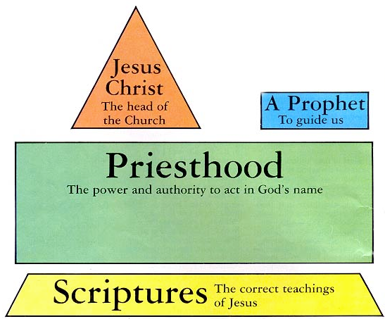
To help you remember the principles on which The Church of Jesus Christ of Latter-day Saints is built, cut out the labeled blocks and glue/tape them where they fit on the dotted outline of the meetinghouse.

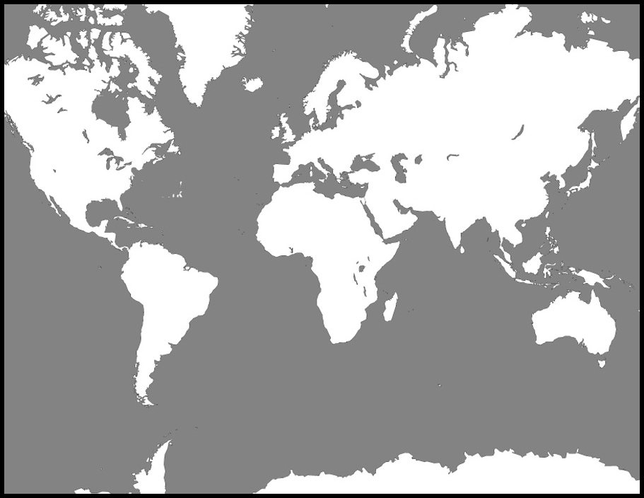
Millions of children around the world belong to The Church of Jesus Christ of Latter-day Saints. They speak different languages, wear different styles of clothes, and live in different kinds of houses. They live on every continent. When we belong to The Church of Jesus Christ of Latter-day Saints, it doesn’t matter where we live, what language we speak, or what kind of building we meet in, because we all believe the same important principles. Put an “x” on the map where you live.

