- The clipart for the 3rd Article of Faith came from here: http://tinyurl.com/3hatq7b
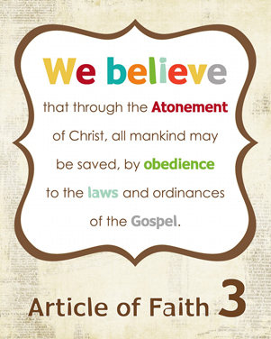

Can you memorize the 3rd Article of Faith? Because Jesus Christ died and was resurrected, we will also be resurrected, and if we keep the commandments, we will be able to live with Jesus and Heavenly Father again someday.
Look up the following scripture and fill in the blanks: “Because ___ _________, ______ ________ _________ __________.”
(John 14:19)
Can you memorize the 3rd Article of Faith? Because Jesus Christ died and was resurrected, we will also be resurrected, and if we keep the commandments, we will be able to live with Jesus and Heavenly Father again someday.
Can you memorize the 3rd Article of Faith? Because Jesus Christ died and was resurrected, we will also be resurrected, and if we keep the commandments, we will be able to live with Jesus and Heavenly Father again someday.
Can you memorize the 3rd Article of Faith? Because Jesus Christ died and was resurrected, we will also be resurrected, and if we keep the commandments, we will be able to live with Jesus and Heavenly Father again someday.
Look up the following scripture and fill in the blanks: “Because ___ _________, ______ ________ _________ __________.”
(John 14:19)
Look up the following scripture and fill in the blanks: “Because ___ _________, ______ ________ _________ __________.”
(John 14:19)
Look up the following scripture and fill in the blanks: “Because ___ _________, ______ ________ _________ __________.”
(John 14:19)


