- Images came from the March 2011 Friend Magazine.
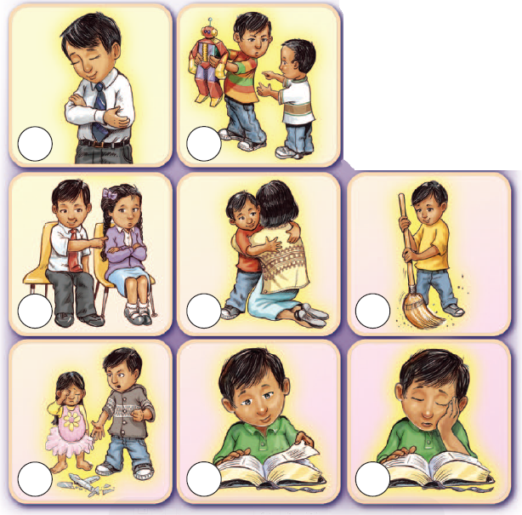

Daniel is learning to show a good example. Draw a happy face in the circles next to the pictures of Daniel showing a good example. Draw a sad face in the circles next to the pictures of Daniel showing a bad example.
Let no man despise thy youth; but be thou an example of the believers (1 Timothy 4:12).
Daniel is learning to show a good example. Draw a happy face in the circles next to the pictures of Daniel showing a good example. Draw a sad face in the circles next to the pictures of Daniel showing a bad example.
Daniel is learning to show a good example. Draw a happy face in the circles next to the pictures of Daniel showing a good example. Draw a sad face in the circles next to the pictures of Daniel showing a bad example.
Daniel is learning to show a good example. Draw a happy face in the circles next to the pictures of Daniel showing a good example. Draw a sad face in the circles next to the pictures of Daniel showing a bad example.
Let no man despise thy youth; but be thou an example of the believers (1 Timothy 4:12).
Let no man despise thy youth; but be thou an example of the believers (1 Timothy 4:12).
Let no man despise thy youth; but be thou an example of the believers (1 Timothy 4:12).

