- Have the children make a list on the back of the card of things they are grateful for.
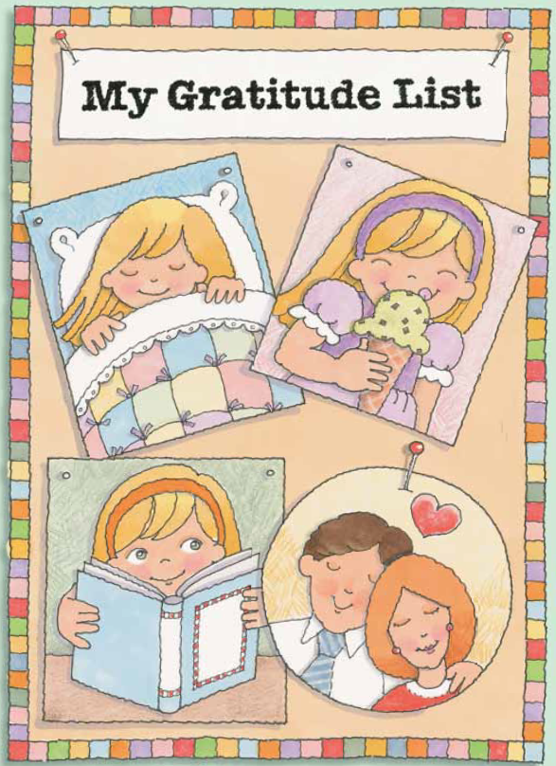

Christina sat down in the chapel with her parents as the organist began playing prelude music. Today she and her family were quiet and sad. That morning Dad told the family that his engineering company might close. Christina knew that his business was struggling, but she hadn’t known how bad things were.
After the sacrament, Sister Stevens, a recently returned missionary, gave the first talk. “One day, about halfway through my mission, I was having a really bad day,” Sister Stevens said. “Nothing was going right.”
Christina thought about her own family’s hard times in the last year. Her father’s business had to cut salaries twice, so he now got paid only part of his original salary. During the summer, her family’s basement had flooded twice, damaging the carpet and furniture in her room. Now not only could she not buy the things her friends could, but she had lost some of her belongings because of water damage.
“Fortunately,” Sister Stevens continued, “my companion wouldn’t let me stay in a bad mood. She suggested that we make a gratitude list. We listed all kinds of things, like peanut butter, soft beds, and letters from home.”
Christina listened in amazement to the small things on Sister Stevens’ list. She had never thought to be grateful for things like peanut butter, beds, or letters.
“By the end of the day, I’d forgotten why I had been in a bad mood,” Sister Stevens said. “It was the best day my companion and I had ever had. We decided to make a gratitude list every day.”
When Christina got home, she made her own gratitude list. She wrote down clean sheets, ice-cream cones, books, and many other things. It wasn’t hard at all to find things to be grateful for.
At dinner that evening, Christina looked across the table at her parents and realized she’d forgotten to list two of her most important blessings.
“I know I don’t say it enough, but I love you,” she said. “And I’m glad you’re my parents.” Dad smiled. “Thank you, Christina.” Mom looked like she was about to cry. “That’s the nicest thing you could have said to me.”
Months later, Dad’s business improved, and he was once again paid his full salary. But Christina never forgot the lesson she had learned about gratitude.
Christina sat down in the chapel with her parents as the organist began playing prelude music. Today she and her family were quiet and sad. That morning Dad told the family that his engineering company might close. Christina knew that his business was struggling, but she hadn’t known how bad things were.
After the sacrament, Sister Stevens, a recently returned missionary, gave the first talk. “One day, about halfway through my mission, I was having a really bad day,” Sister Stevens said. “Nothing was going right.”
Christina thought about her own family’s hard times in the last year. Her father’s business had to cut salaries twice, so he now got paid only part of his original salary. During the summer, her family’s basement had flooded twice, damaging the carpet and furniture in her room. Now not only could she not buy the things her friends could, but she had lost some of her belongings because of water damage.
“Fortunately,” Sister Stevens continued, “my companion wouldn’t let me stay in a bad mood. She suggested that we make a gratitude list. We listed all kinds of things, like peanut butter, soft beds, and letters from home.”
Christina listened in amazement to the small things on Sister Stevens’ list. She had never thought to be grateful for things like peanut butter, beds, or letters.
“By the end of the day, I’d forgotten why I had been in a bad mood,” Sister Stevens said. “It was the best day my companion and I had ever had. We decided to make a gratitude list every day.”
When Christina got home, she made her own gratitude list. She wrote down clean sheets, ice-cream cones, books, and many other things. It wasn’t hard at all to find things to be grateful for.
At dinner that evening, Christina looked across the table at her parents and realized she’d forgotten to list two of her most important blessings.
“I know I don’t say it enough, but I love you,” she said. “And I’m glad you’re my parents.” Dad smiled. “Thank you, Christina.” Mom looked like she was about to cry. “That’s the nicest thing you could have said to me.”
Months later, Dad’s business improved, and he was once again paid his full salary. But Christina never forgot the lesson she had learned about gratitude.

