- Images of boy and girl come from Primary 3 Manual, Lesson 25.

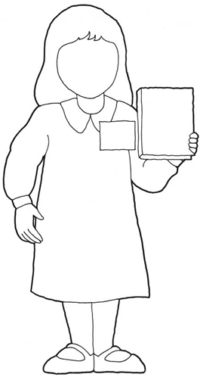
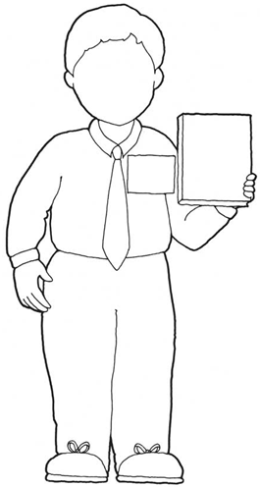

1. Memorize at least two scriptures.
2. Invite nonmember friends to come to your home after school to play.
3. Start, or add to, your missionary fund.
4. Tell someone the Joseph Smith story.
5. Write letter to missionary.
6. Offer to do service without pay for nonmember neighbor.
7. Pray morning and night.
8. Memorize hymn from the Church hymnbook.
9. Learn to fix flat tire on bike.
10. Attend Church meetings and listen well.
11. Obey Word of Wisdom.
12. Attend friend’s baptism.
13. Pray for missionaries.
14. Learn to mend your clothing and sew on buttons.
15. Say hello to two new people at school.
16. Give someone Book of Mormon with your testimony written inside.
17. Share “Friend” Magazine with someone.
18. Suggest that nonmember or inactive family be invited to family home evening.
19. Learn to play or sing “I Want to Be a Missionary Now” (Friend, October 1984, page 46).
20. Bear your testimony in sacrament meeting.

“Young men, I admonish you to prepare for service as a missionary. … Young sisters: … you also make a valuable contribution as missionaries.”
- President Thomas S. Monson
Write your name on the name tag.
Draw a face on your missionary.
Write “The Book of Mormon” on the book.
Cut out your missionary and glue or tape on card.
Make a check mark by at least three items (or more) that you'll do this week to prepare to be a missionary. During family home evening, try challenging family members to do some of the items from the list.

Complete items 1-5.
Write your name on the name tag.
Draw a face on your missionary.
Write “The Book of Mormon” on the book.
Cut out your missionary and glue or tape on card.
Make a check mark by at least three items (or more) that you'll do this week to prepare to be a missionary. During family home evening, try challenging family members to do some of the items from the list.

1. Memorize at least two scriptures.
2. Invite nonmember friends to come to your home after school to play.
3. Start, or add to, your missionary fund.
4. Tell someone the Joseph Smith story.
5. Write letter to missionary.
6. Offer to do service without pay for nonmember neighbor.
7. Pray morning and night.
8. Memorize hymn from the Church hymnbook.
9. Learn to fix flat tire on bike.
10. Attend Church meetings and listen well.
11. Obey Word of Wisdom.
12. Attend friend’s baptism.
13. Pray for missionaries.
14. Learn to mend your clothing and sew on buttons.
15. Say hello to two new people at school.
16. Give someone Book of Mormon with your testimony written inside.
17. Share “Friend” Magazine with someone.
18. Suggest that nonmember or inactive family be invited to family home evening.
19. Learn to play or sing “I Want to Be a Missionary Now” (Friend, October 1984)
20. Bear your testimony in sacrament meeting.

“Young men, I admonish you to prepare for service as a missionary. … Young sisters: … you also make a valuable contribution as missionaries.”
- President Thomas S. Monson


Complete items 1-5.

