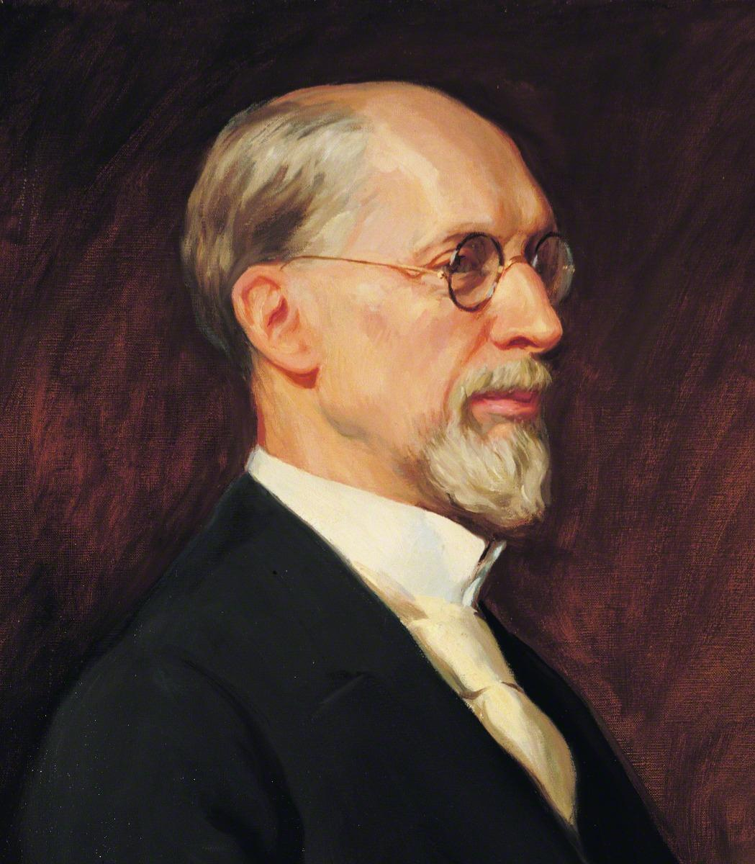
President George Albert Smith’s Goals
- “I would be a friend to the friendless and find joy in ministering to the needs of the poor.”
- “I would visit the sick and afflicted and inspire in them a desire for faith to be healed.”
- “I would teach the truth to the understanding and blessing of all mankind.”
- “I would seek out the erring one and try to win him back to a righteous and a happy life.”
- “I would not seek to force people to live up to my ideals but rather love them into doing the thing that is right.”
- “I would live with the masses and help to solve their problems that their earth life may be happy.”
- “I would avoid the publicity of high positions and discourage the flattery of thoughtless friends.”
- “I would not knowingly wound the feeling of any, not even one who may have wronged me, but would seek to do him good and make him my friend.”
- “I would overcome the tendency to selfishness and jealousy and rejoice in the successes of all the children of my Heavenly Father.”
- “I would not be an enemy to any living soul.”
- “Knowing that the Redeemer of mankind has offered to the world the only plan that will fully develop us and make us really happy here and hereafter I feel it not only a duty but a blessed privilege to disseminate this truth.”

President George Albert Smith’s Goals
- “I would be a friend to the friendless and find joy in ministering to the needs of the poor.”
- “I would visit the sick and afflicted and inspire in them a desire for faith to be healed.”
- “I would teach the truth to the understanding and blessing of all mankind.”
- “I would seek out the erring one and try to win him back to a righteous and a happy life.”
- “I would not seek to force people to live up to my ideals but rather love them into doing the thing that is right.”
- “I would live with the masses and help to solve their problems that their earth life may be happy.”
- “I would avoid the publicity of high positions and discourage the flattery of thoughtless friends.”
- “I would not knowingly wound the feeling of any, not even one who may have wronged me, but would seek to do him good and make him my friend.”
- “I would overcome the tendency to selfishness and jealousy and rejoice in the successes of all the children of my Heavenly Father.”
- “I would not be an enemy to any living soul.”
- “Knowing that the Redeemer of mankind has offered to the world the only plan that will fully develop us and make us really happy here and hereafter I feel it not only a duty but a blessed privilege to disseminate this truth.”

